IB Biology Name _______________________________

Osmometers Period _______ Date _________________

Examine the diagram of an experiment performed to demonstrate osmosis.

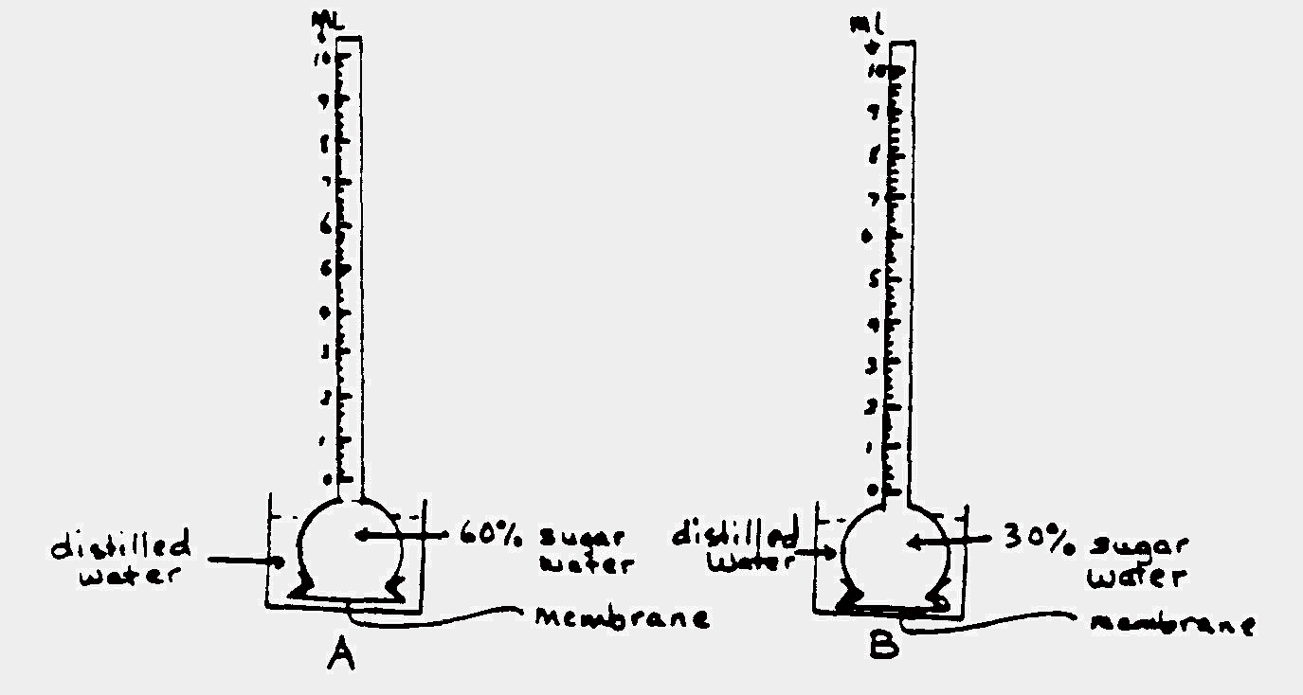

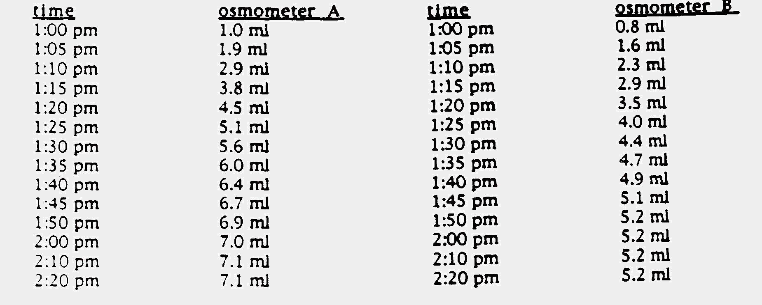

1. Make a graph of these results. Be sure to include a descriptive title, labels, units, key and annotation.

2. What is the manipulated variable in this experiment?

3. What is the responding variable in this experiment?

4. What caused the level of liquid in the osmometers to rise?

over→
5. Calculate the average rate of osmosis in each osmometer during the first 20 minutes. Show work!

6. Calculate the average rate of osmosis in each osmometer during the last 20 minutes. Show work!

7. Explain the variations in these rates. Address the variation in rates between osmometer A and B as well as
the variation in rates between the beginning and the end of the experiment.

